TECHNICAL Writing Course
The English Department

Academic Year 2025-2026
Technical Writing for Success
Darlene Smith-Worthington & Sue Jefferson

Chapter: 7 & 10
Topic: Instructions and Web Design
Work Sheet # 8
PERSONAL WEB PORTFOLIO PLANNING WORKSHEET
Student A’s name: Seif ElTohamy Student B’s name: Youssef Nagui

Website / Document Planning Checklist
This section outlines the grading criteria for your website project. Each category is worth 1 mark, for a total of 5 marks.
Use this checklist as your guide. Strong websites are built through careful planning — clear audience awareness, logical structure, effective navigation, purposeful design, and organized content.
Complete all planning sections thoughtfully. This is not about ticking boxes; it is about demonstrating your thinking as a technical communicator.

Audience Analysis (1 Mark)
☐ Identify the target audience and the role they will play.
☐ Identify the questions the audience will have about the content.

Structure & Organization (1 Mark)
☐ Identify probable nodes (main sections/pages) for the site or document.
☐ Create a flow chart that shows hierarchy and navigation paths.

Navigation & Usability (1 Mark)
☐ Plan navigation paths that give readers the freedom they need.
☐ Plan features (screen and text elements) that help readers find information easily.

Layout & Visual Design (1 Mark)
☐ Create a screen template that groups similar information clearly.
☐ Choose appropriate fonts and colors for headings and text.
☐ Choose a neutral, readable background.

Content Presentation (1 Mark)
☐ Determine which visual aids are needed to support the information.
☐ Write text in manageable chunks.
PART 1 — Your Target User
1- Who is your primary visitor?
HR Recruiter
2- What does this person want to see in 10 seconds?
My name, field/role, and at least one strong project or skill enough to decide if I’m worth a closer look.
3- What would confuse or frustrate them?
- No clear job title or area of expertise on the homepage
- Too much text before getting to actual work samples
- Broken links or missing project pages
- No contact information or a hard-to-find contact page
- A cluttered layout that buries the most important information
PART 2 — Purpose & Homepage Message
4- One-Sentence Purpose of My Portfolio
"My portfolio supports HR recruiters and hiring managers by showing my technical skills, completed projects, and professional background in a clear and accessible format."\

5- Homepage Slogan (Short & Clear)
"Turning skills into solutions"
6- First 50 Words (Scannable Intro Paragraph)
Write a short paragraph with keywords early:
"Hi, I'm Seif — a computer science student with hands-on experience in business and marketing. I build systems that are practical, clean, and purposeful. Browse my projects, learn about my background, or get in touch — I'd love to connect."

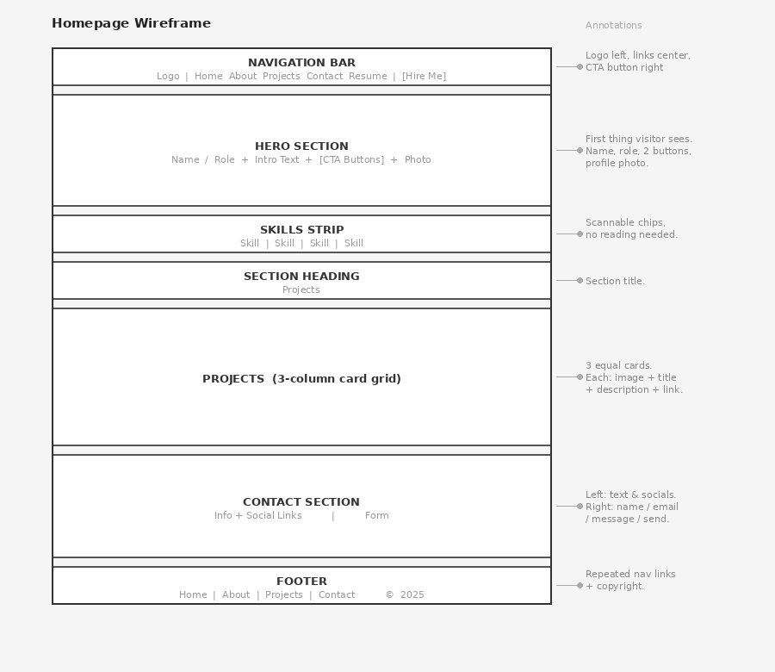

PART 3 — Site Structure (Information Architecture)
7- List Your Main Pages
- Home
- About
- Projects
- Contact
- Resume

8- FLOWCHART AREA
Draw your site structure here:
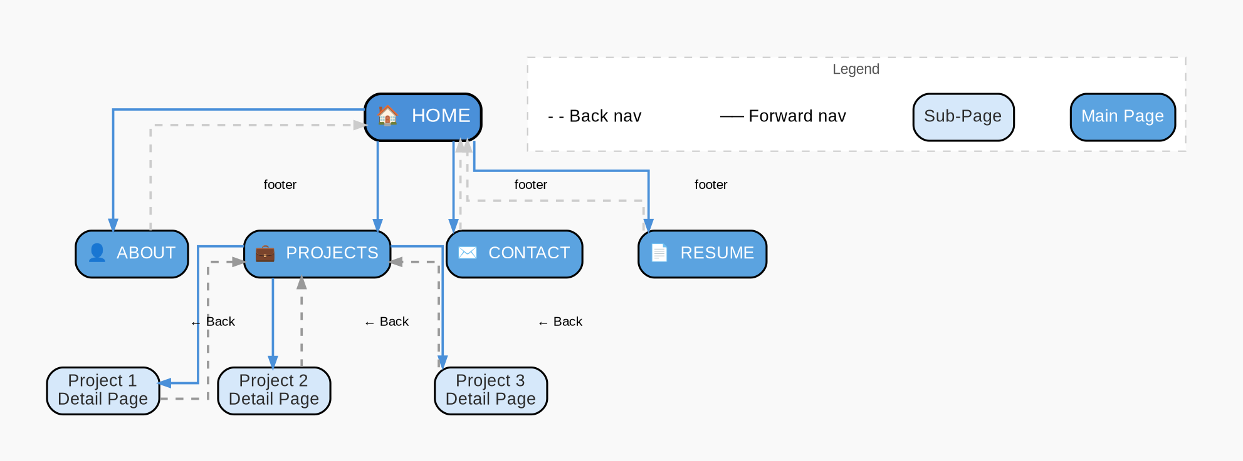

PART 4 — Homepage Wireframe (Layout Sketch)
Sketch your homepage layout below.


PART 5 — Navigation & Usability Check
Answer:
✔ Can users return home easily?
☑ Yes — logo and "Home" link are visible in the nav bar on every page.
✔ Can they reach important content in ≤4 clicks?
☑ Yes — every main page is one click from the nav bar; individual projects are two clicks from Home.
✔ Is your layout uncluttered?
☑ Yes — one column of content, generous white space, no side bars or pop ups.

Part 6: Performance & Responsiveness Plan
How will you ensure:
Fast loading: Use compressed images (under 200KB each), avoid heavy animations, and choose a lightweight platform like Google Sites or a minimal Wix template with no unnecessary plugins.
Mobile friendly layout: Use a single column layout that stacks naturally on small screens, choose a platform with built-in responsive templates, and test the site on a phone before publishing.

PART 7 — Accessibility & Global Awareness
✔ Will you add alt text for images? ☑ Yes
✔ Is your font readable? ☑ Yes — Arial or Inter at 14pt minimum for body text.
✔ Are colors high contrast? ☑ Yes — dark charcoal #2C2C2C text on soft white #F9F9F9 background meets WCAG contrast standards.
One accessibility consideration: All navigation links will be clearly labeled with descriptive text (e.g. "View my Projects" rather than "Click here") so that screen readers can interpret and announce them meaningfully to visually impaired visitors.

PART 8 — Creativity & Differentiation
What makes your portfolio unique?
It is designed specifically with the recruiter's limited time in mind, the most important information (name, role, top project) is visible without scrolling. Every section answers a question the recruiter is already asking: Who are you? What can you do? Can I contact you easily?
What visual style will you use?
☑ Minimalist combined with Card based project display, clean and professional, with just enough visual structure to guide the eye without overwhelming a first-time visitor.

🔹 FINAL SELF-CHECK
In 10 seconds, does my homepage:
☑ Clearly show who I am: name and role in the header
☑ Clearly show what I do: skills icons and project cards visible above the fold
☑ Clearly show where to click next: a prominent "View My Work" button leads directly to the Projects page

